1. WAP to implement greater of 2 numbers using Ternary operator (Mandatory)2.

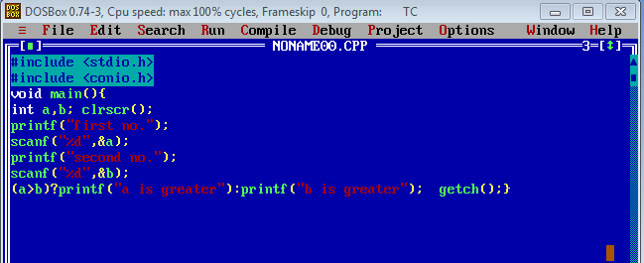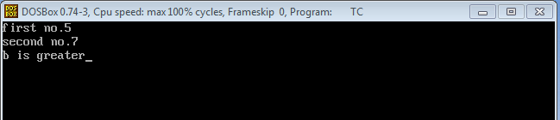

1. WAP to reverse a given number (i.e Input 1824, Output 4281) (mandatory)

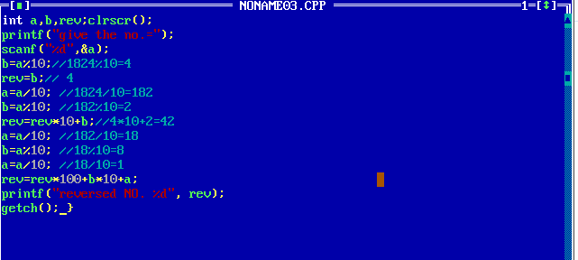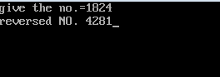

1. WAP to sum all the digits of a number (i.e Input 1924 Output 15) (Mandatory)

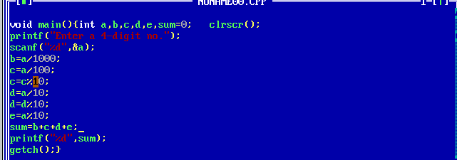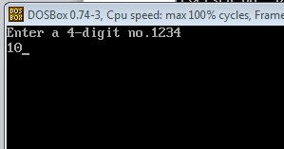

1. WAP to implement greatest of 3 numbers using Nested If-Else. (Mandatopry)

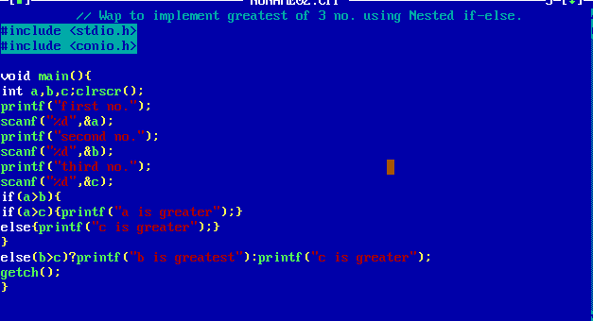

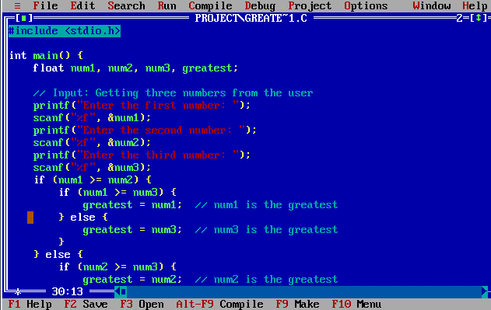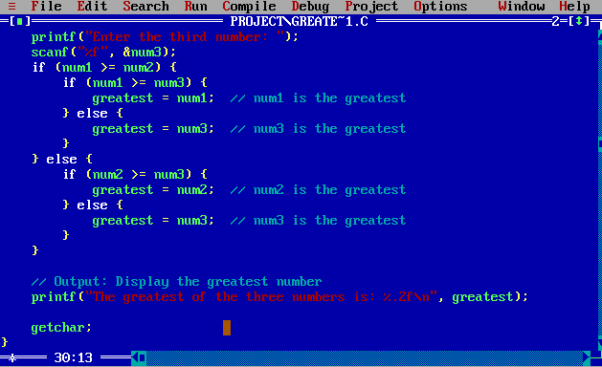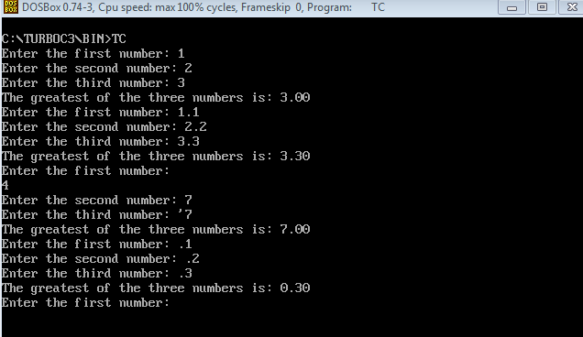

1. WAP using ternary operator AND if-else to check if the given number is +ve/-ve/zero

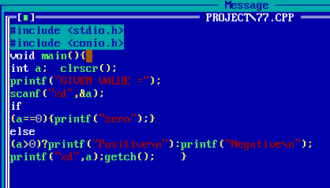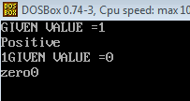

1. WAP to check the divisibility of a number by 0/5/10/3

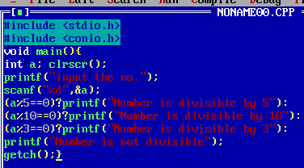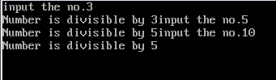

1. WAP to check if the entered character is Alphabet or not (Mandatory)

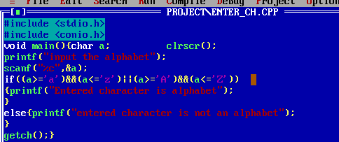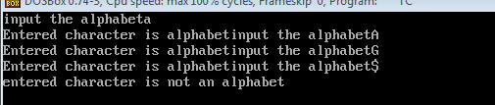

1. WAP to check whether the ASCII value of the character entered is even or odd.

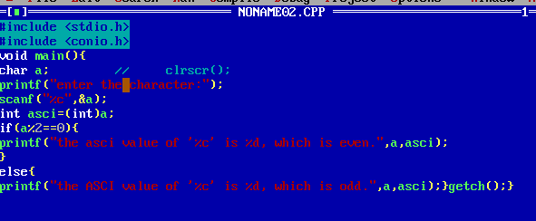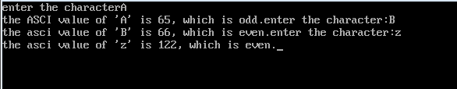

1. **WAP to check if the character is vowel or consonant9. WAP to check if the character is vowel or consonant**

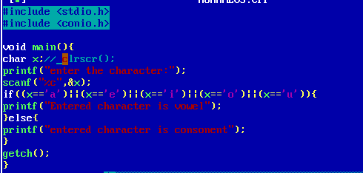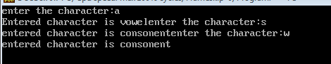

**Write a C program to check whether the triangle is equilateral, isosceles or scalene triangle.**

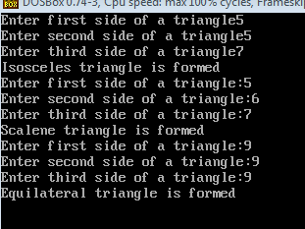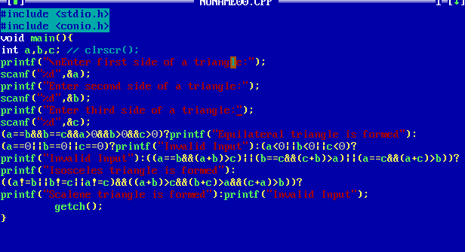

1. **Write a C program to check if the roots of a quadratic equation are real or imaginary**

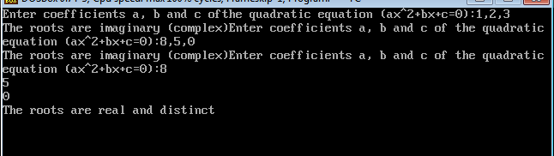

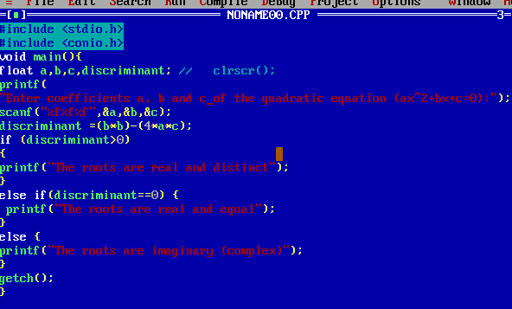

**12.**

**Write a C program to calculate profit or loss.**

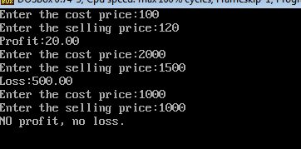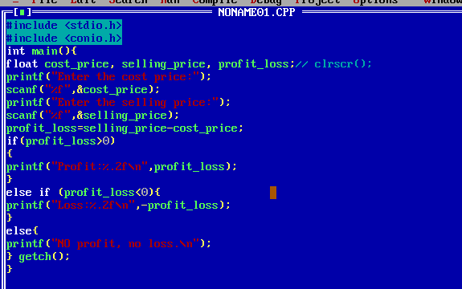

**13.**

**Write a C program to input marks of five subjects Physics,**

**Chemistry, Biology, Mathematics and Computer. Calculate**

**percentage and grade according to following:**

**Percentage >= 90% : Grade A**

**Percentage >= 80% : Grade B**

**Percentage >= 70% : Grade C**

**Percentage >= 60% : Grade D**

**Percentage >= 40% : Grade E**

**Percentage < 40% : Grade F**

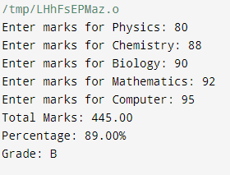

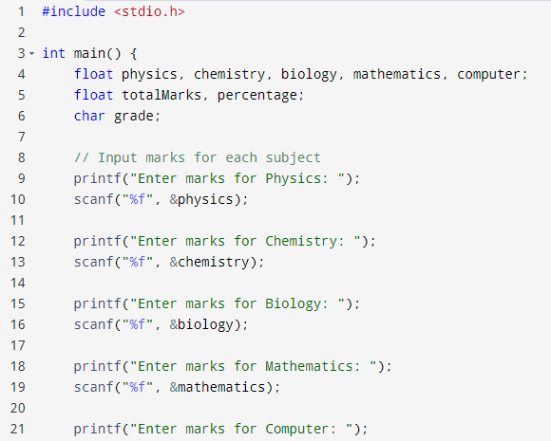

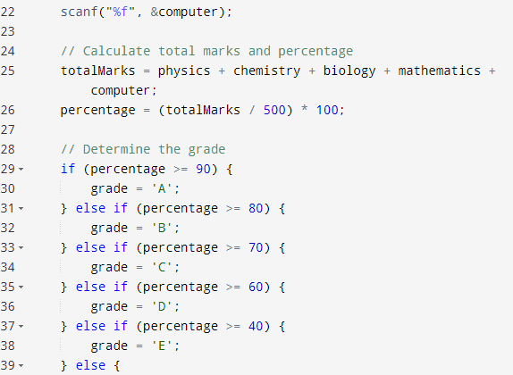

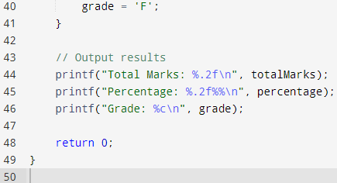

**14.**

**Write a C program to input basic salary of an employee and**

**calculate its Gross salary according to following:**

**Basic Salary <= 10000 : HRA = 20%, DA = 80%**

**Basic Salary <= 20000 : HRA = 25%, DA = 90%**

**Basic Salary > 20000 : HRA = 30%, DA = 95%**

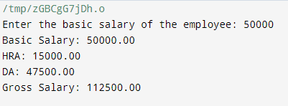

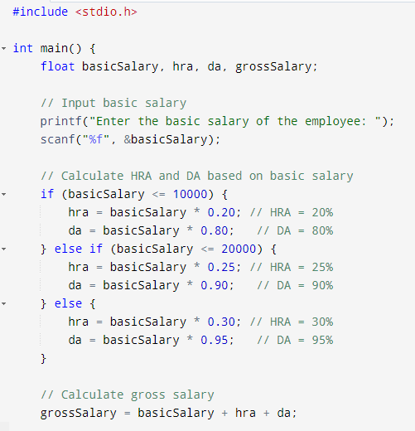

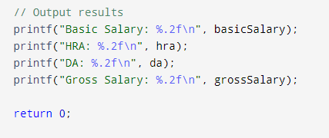

**15.**

**Write a C program to input electricity unit charges**

**and calculate total electricity bill according to the given**

**condition:**

**For first 50 units Rs. 0.50/unit**

**For next 100 units Rs. 0.75/unit**

**For next 100 units Rs. 1.20/unit**

**For unit above 250 Rs. 1.50/unit**

**An additional surcharge of 20% is added to the bill**

**Output:**

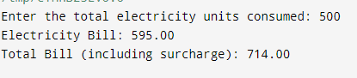

**Input**:

